We need your help to raise funds for our organization, to better serve our Wood County Communities. Please look at the options below and choose the one that works best for you. Thank you in advance for your support!

STEP 1: Company/Sponsor
Name (as it should appear on signage) ______________________________________________
Contact Person:______________________________________ Phone: _________________
Address: ______________________________________________________________________
City: ________________________________________ Zip: __________________________

STEP 2: Choose Your Sponsorship Level

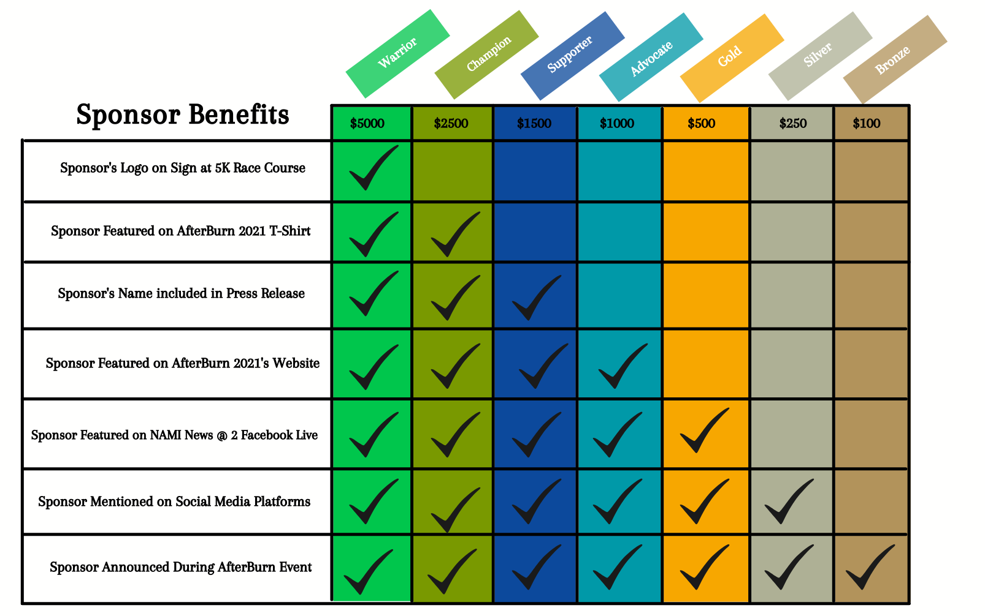

Sponsorship Level/Amount: ______________________________________________________

STEP 3: Choose Your Payment
[ ] Check payable to NAMI Wood County OR Charge my [ ] Visa [ ] MasterCard
Account #: ________________________________________________ Exp. Date: ___________
Name as it appears on card: _______________________________________________________
Signature: _____________________________________________________________________

